Docker Task -3
Task Description:
Create a custom docker image for nginx and deploy it using docker compose, where the volume bind mount should be at /var/opt/nginx location. Push the created custom docker image to your docker-hub.
O/P:
- Create Custom NGINX Content:
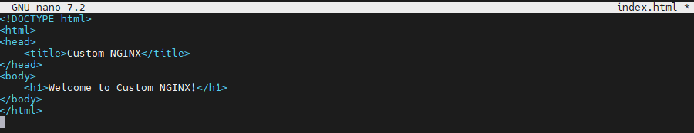
- Create a Dockerfile:
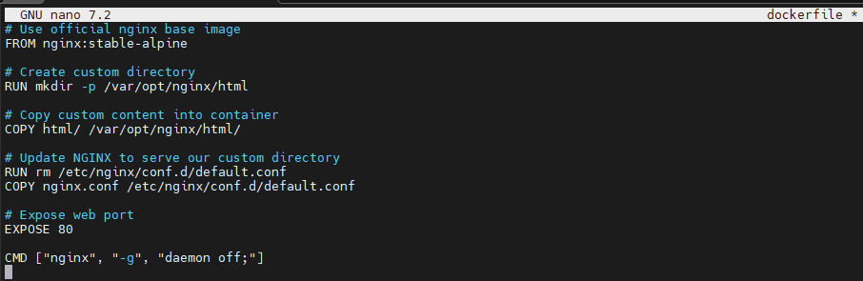
- NGINX Configuration:

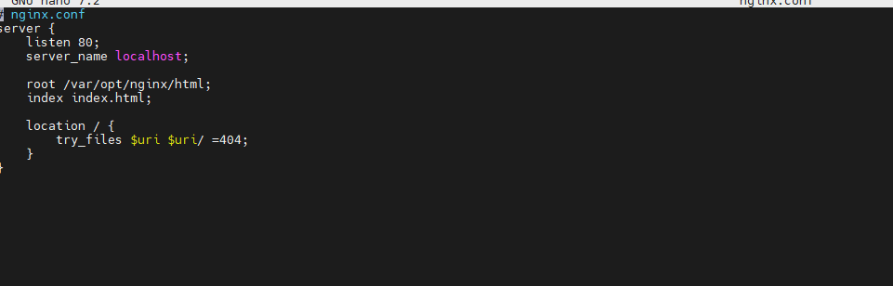
- Create Docker Compose File:
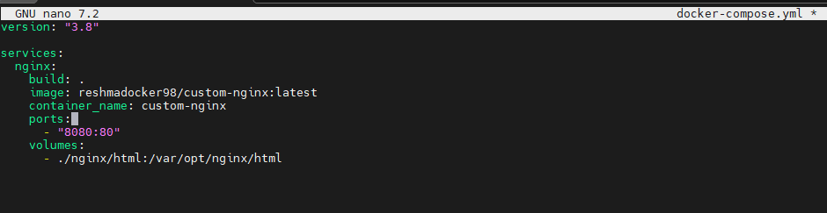
- Build and run with Docker Compose:
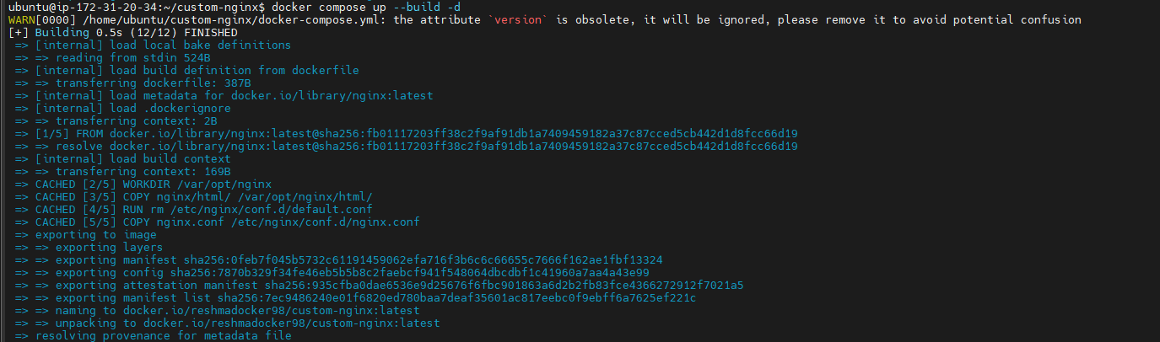
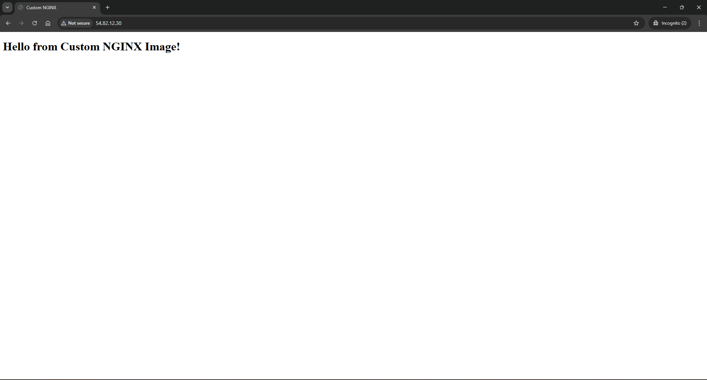
- Push Custom Image to Docker Hub:
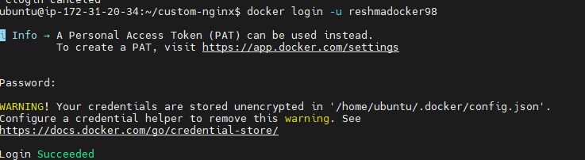
- Build the Image with your Namespace:
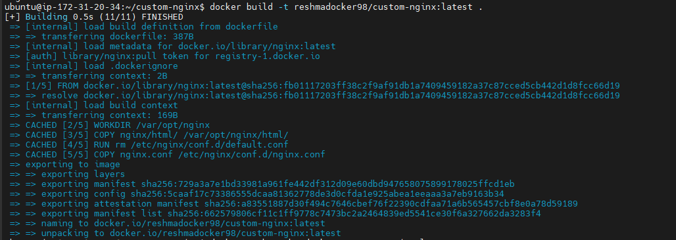
- Push the Image:
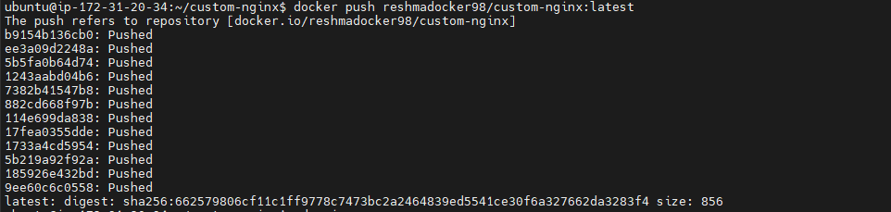
- Image is on Docker Hub:
